SITE MAP BUILDING

Welcome to week two! This week, we’re building your site map—which is essentially a map of all the pages on your website. In making the site map, we’ll decide what pages you want to have on your site, what order those pages will appear in your navigation, and what we’ll call the pages in your navigation.

(I’ve included a PDF example site map in this week’s downloads if you’d like to go take a peek now.)

Determining Your Pages
To create your site map, we’ll start by identifying the pages you want on the site. I usually do this with sticky notes, but index cards and even paper (or a Word document) can work just as well. Choose whatever you’re most comfortable with and start here:

1. On each sticky note (or index card), write one page that you think you want/need to have on your site.

2. Open up your content questionnaire.

Write a sticky note for each thing your business is selling. If you’re creating a blog and don’t have a set of products or services, write down major topics instead.

Write a sticky note for each of your website goals (“Join my newsletter,” “request a consult,” “sign up for classes,” etc.).

Go take a look at the competitor/colleague sites you admire (the ones you identified in the questionnaire) and write down any additional pages they have on their sites (feel free to skip over pages that are clearly not relevant to your business).

3. In a separate document, list the common questions people ask about your business.

These could be anything from “where are you located?” to “do you have any samples?” to “when is your next session/class?”

Once you have the common questions listed out, compare them one by one to the sticky notes. Do you already have a sticky note page that will answer that question? If yes, note the name of the sticky note page beside the question in your document (you’ll be coming back to those during the content phase). If no, create a new sticky note with a page that will answer that question.

For example, if people often ask where you’re located (if your business has a physical location), you’ll probably want to add an “Our Location” or “Location” sticky note. If people often ask when your next course is, add an “Upcoming Courses” or “Course Dates” sticky note.

4. Now, ask yourself: what do my users need to know in order to complete [your goal for them]?

Make a list of everything they need and compare it to your pages. Do you have a page that meets each need? If there’s something missing, add it.

Honing Your Pages
Okay, so now that you have a plethora of sticky notes, it’s time to hone in on the pieces you truly need.

1. Are there any duplicate sticky notes? Take those out now.
2. Are there any sticky notes that really aren’t relevant to your business? (For example: a colleague you admire might have an “illustrations” page on their site…but do you really need this?) Take those out now.

3. Are there any sticky notes that should logically be combined? (For example: a page with your business address should also be the page with map, directions, and a contact form. If you started with these as separate sticky notes, now’s the time to combine them.)

Once you’ve taken out the obvious duplicates and combined the logical combinations, go through the sticky notes one by one, asking yourself:

1. Does this page meet a user need?

And

2. Does this page contribute to a business goal?

If the answer to those things is no, it’s time to ditch that sticky note.
For example: Do board member profiles truly meet a user need? Does a page about the history of music actually meet a business need or help a user decide whether to sign up for violin lessons?

Simple sites do better—both with users and search engines—so be ruthless here. Cut the things you don’t need. And don’t forget, you can always add things in later.

Prioritizing & Ordering Your Pages
Once you’ve eliminated the sticky notes you don’t need, it’s time to prioritize them and create your actual site map (I do this by sticking the sticky notes on a wall or fridge in the order I want them to appear on the site—like the site map example I sent you, but with sticky notes—but you can also do this on a table or floor with index cards or on a scratch pad or even in a Word document).

When ordering the pages, there are two things to consider:

1. Which pages are most important to user needs and business goals?

2. What are the industry standards people are used to?

To start, go ahead and order the pages by importance. Which pages matter most to the user? Which pages actually drive your goals?

The most important pages will be the main navigation on your site. The items at the beginning and end of your navigation (left and right) are the most important. Psychology tells us that people give more importance to things at the beginning and end of a list—and site navigation works the same way.

For example: on my site, one of my primary goals is to sell travel guides. Thus, Travel Guides is the very first thing you see in the navigation after Home. The blog is the second most important thing, so Blog comes next. Destinations is the least likely to help me reach a goal (though it does help users navigate the site), so it’s placed in the middle.

Less important pages or pages that dive deeper into a topic can become sub-pages below the main navigation. For example: on my site, Gigi Who? is an important top-level page. Books I Love is less important and feels like a natural extension of a section about me, so it appears in the sub-navigation below.

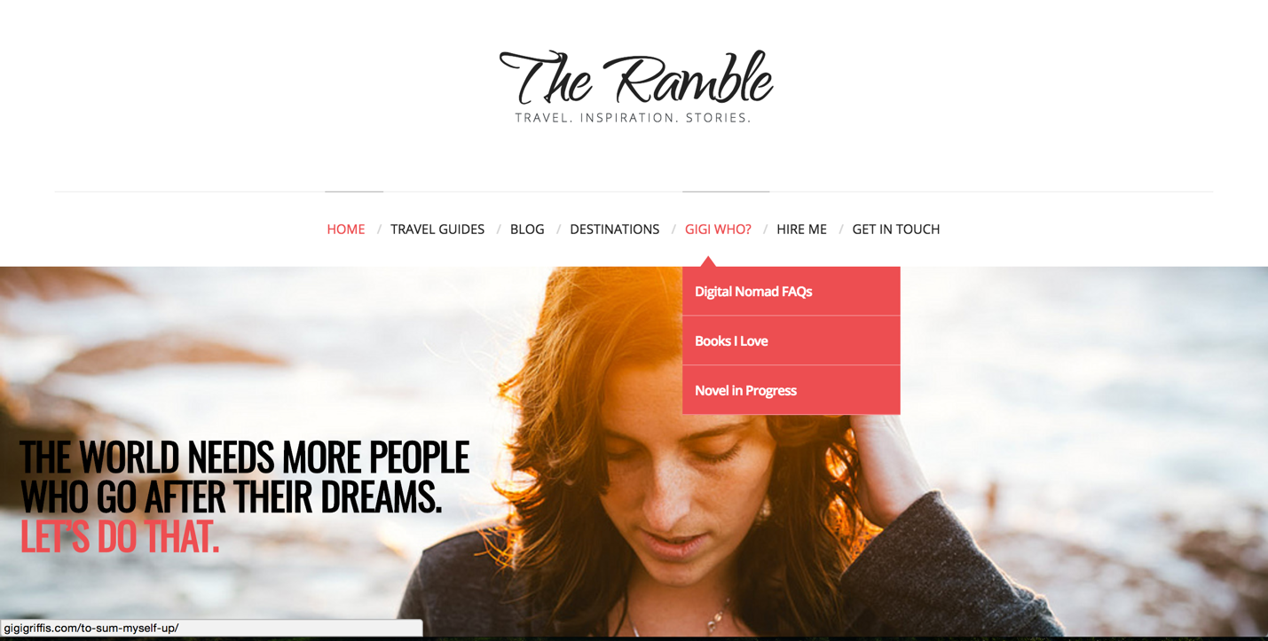

Once you’re feeling good about the order importance-wise, let’s talk standards: Home is pretty much always the far left page. People expect to see it there and if they’re trying to get back to your homepage, this makes it easy. Contact is almost always the far right option. This is another standard people are used to.

Naming Your Pages
Finally, once you feel good about the pages and their order, it’s time to perfect the language. The most important thing when it comes to navigation is clarity, so now let’s go through each page and ask:

1. Is this title clear? What does a person think they will find when they click on this?
For example: I did a recent project for a client who wanted to sell more books. She has a great blog full of information and the books she writes (children’s books) are adorable. So why wasn’t she selling more books? Part of the reason was probably her navigation. There was no page for “Books” or “Book” or “Children’s Books” – or anything related to books. Instead, she had named her book page “Store” and as a first-time site user, I had no idea what I’d find on that page (a travel store since her blog is about travel? A list of her favorite products?). When you craft your navigation, try to see it with first-time-visitor eyes: if you didn’t know a thing about your business, what would you think was on this page?

If you’re having trouble with this, get opinions! Go on your Facebook or Twitter account or email friends and ask them “If you got to a website and saw a link to “[Your link title here],” what would you expect to find on that page?

2. Could this title be more specific?

Sometimes part of getting clear is simply getting more specific. A page called “Products” tells the user that your products are listed there…but it still isn’t crystal clear. What kind of products do you sell? What will people find there?
So when you come across a sticky note that feels generic, as yourself if there is a simple way to make it more specific.

For my site, for example, Books is good, but Travel Guides is even better. About is good, About Gigi is better (eliminating the question “about what/who?”).

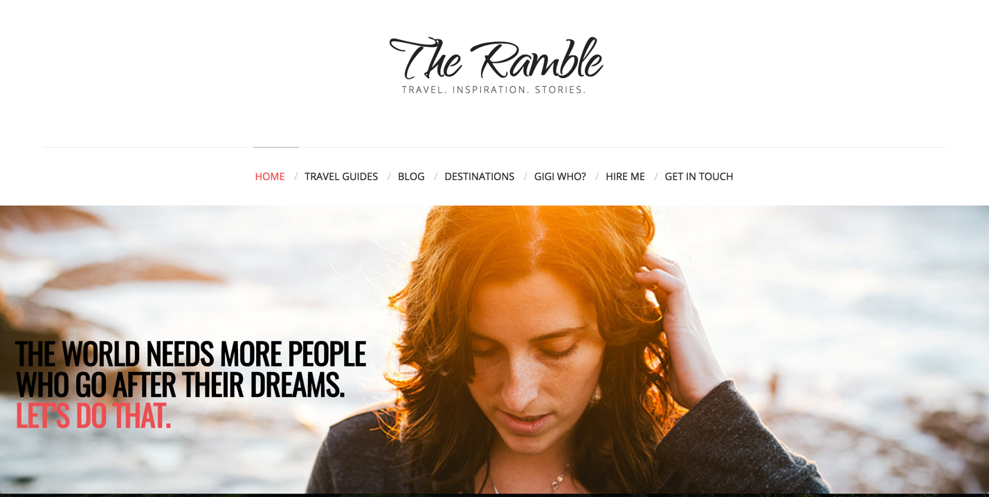

So instead of Products, consider something like Fashion Products or Jewelry or Handmade Soaps or Art for Sale. Instead of Services, consider Music Lessons or Violin Lessons or Website Workshops or Website Design Services.

And fun fact: the more specific you can get for users, the better search engines will rank you. They respond better to specifics as well.

