YOUR GUIDE TO BASIC SEO

SEO (Search Engine Optimization) is about making sure your website ranks high for the things your ideal clients are searching for online. There are a lot of moving parts—a lot of things you can do to help your site rank well on search engines—but to start, there are three foundational pieces we’re going to cover today:

1. SITE SPEED
Faster sites rank better. Whoever designed and developed your site for you can probably help you figure out if your site is optimized for speed, but there are also things you can do on a day-to-day basis. The biggest one is making sure that any time you add a photo to your site, it is sized correctly. Large image files can cause your website to load slowly and can impact your Google rankings.

To find out what size your image files should be, the easiest thing to do is ask your designer for the image sizes on the current site.

To resize images yourself, you can use any photo editing software that allows resizing. I use and recommend Photoshop, but there are also free options out there and many people love them.

To check your current images and see if they’re sized correctly, you can go to your site, left-click on the image and select Open Image in New Tab. This should show you the image in full size. If it is larger than it appears on your website, it should be resized.

2. ON-SITE SEO
When it comes to SEO, one of the most important things to think about is your site’s content. This is where you can have some of the biggest impact on your rankings. Here are the basics you should consider on each page:

CONTENT
When writing your page content, make sure to:

:: Be very clear about what that page is about
If, for example, the page is about orthodontic services, make sure to use the phrase orthodontic services several times on the page—including once in the page headline. This will help readers know exactly what they’re reading about and it will help search engines rank you properly.

:: Keep paragraphs short and make your page scannable
Readers should be able to easily skim the page for the info they need, since most internet users are in a hurry. Google knows this and ranks sites higher when they are easy to scan. This means short paragraphs, clear headlines, and good, clear subheaders.

:: Use plain language
Most people search in search engines using plain language. Using that same plain language on your site can help you rank well for those searches.

HEADLINES
:: Always choose clarity over cleverness

:: Be descriptive
For example: “Orthodontic Services” is more descriptive than “Services.

:: In the code, your headlines should be <h1> and <h2> tags.
During our training, I’ll show you how to check.

ALT TAGS
:: All site images should have ALT Tags
ALT tags are short descriptions of the images on your site. They go into the code behind the image and tell Google what that image is (and, thus, how to rank the image and what to rank it for).

ALT tags are also used by screen readers for visually disabled persons and help your site become ADA compliant.

:: Keep ALT tags short and descriptive

TITLE TAGS
:: All links should have title tags
Title tags, much like ALT tags, are little descriptions that go in the code behind your site. They tell Google what your link is linking to and help Google rank your site and the sites of those you link to.

Title tags are also used by screen readers for visually disabled persons and help your site become ADA compliant.

:: Keep title tags short and descriptive
For example: “orthodontic services by Dr. Johnson” rather than “services”

BROWSER TITLES
:: Write a short, descriptive browser title for every page on your site
The browser title is what shows up in Google (and other search engines) when your site comes up in their search results. A short, descriptive browser title can tell searchers they’ve found what they’re looking for and get them to click into your site. This will help not only your ranking, but also help you entice web users to click through to your site once the search results appear in Google.

In the below example, “Orthodontists in Portland – Yelp” is the browser title.

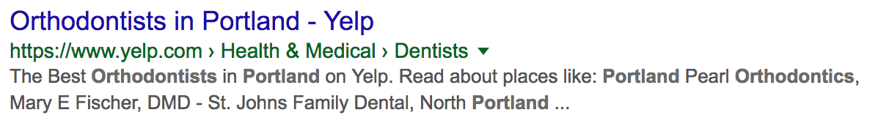

META DESCRIPTIONS
:: Each page on your site should have a short meta description
Much like browser titles, descriptions help you control how your search results appear in Google. In the example above, the meta description is “The Best Orthodontists in Portland on Yelp. Read about…” You have control over what this text says for each of your pages.

:: Meta descriptions should be 160 characters or less
After that, Google cuts them off with a …

3. INBOUND LINKS
The final foundational piece of SEO is linking. Every time a relevant website links to your site, Google considers it social proof that you are providing something valuable. The more relevant, genuine inbound links you have, the better you’ll rank.

Here are some ideas of where to get inbound links:

:: Partner sites

:: Databases or listings

:: Your local Chamber of Commerce

:: Articles or interviews online

ADDITIONAL RESOURCES
If you want to make sure Google sees your changes, you can ask them to re-crawl your site.

These basics should get you started and point you in the right direction. If you would like a more in-depth look at on-page SEO, this article from SEOMoz is fairly extensive.

If you haven’t already added your business to Google Maps, this can also be helpful in making yourself findable. Here is Google’s how-to page.

