HOW TO GET YOUR HOSTING & DOMAIN NAME

1. Have a few domain name options in mind (see video for what a domain name is, why it matters, and how to choose one).

2. Go to NameCheap.com/?aff=78698.

3. At the top of the screen, mouse over Hosting and choose Shared Hosting.

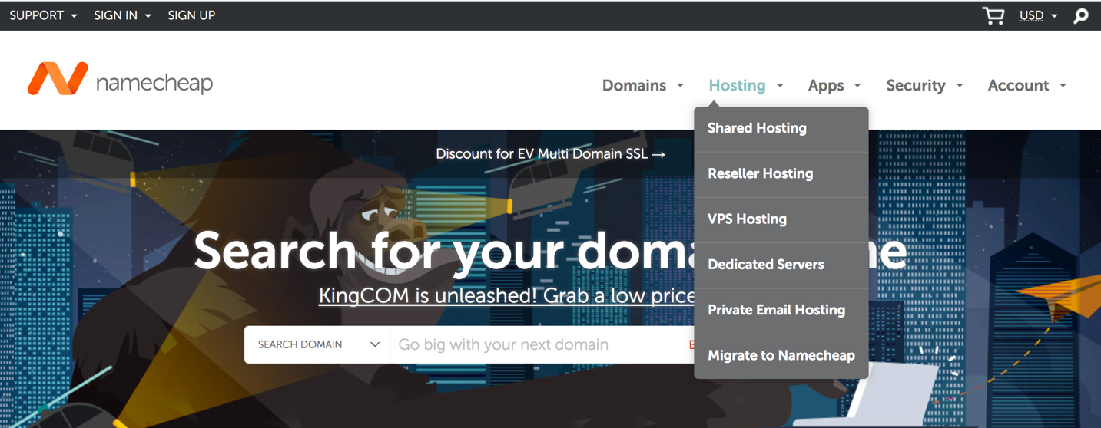

4. On the next screen, I recommend selecting the Value plan, which allows you to host up to three websites with 20GB of space (which is quite a lot and should be fine unless you’re planning to host more than three sites).

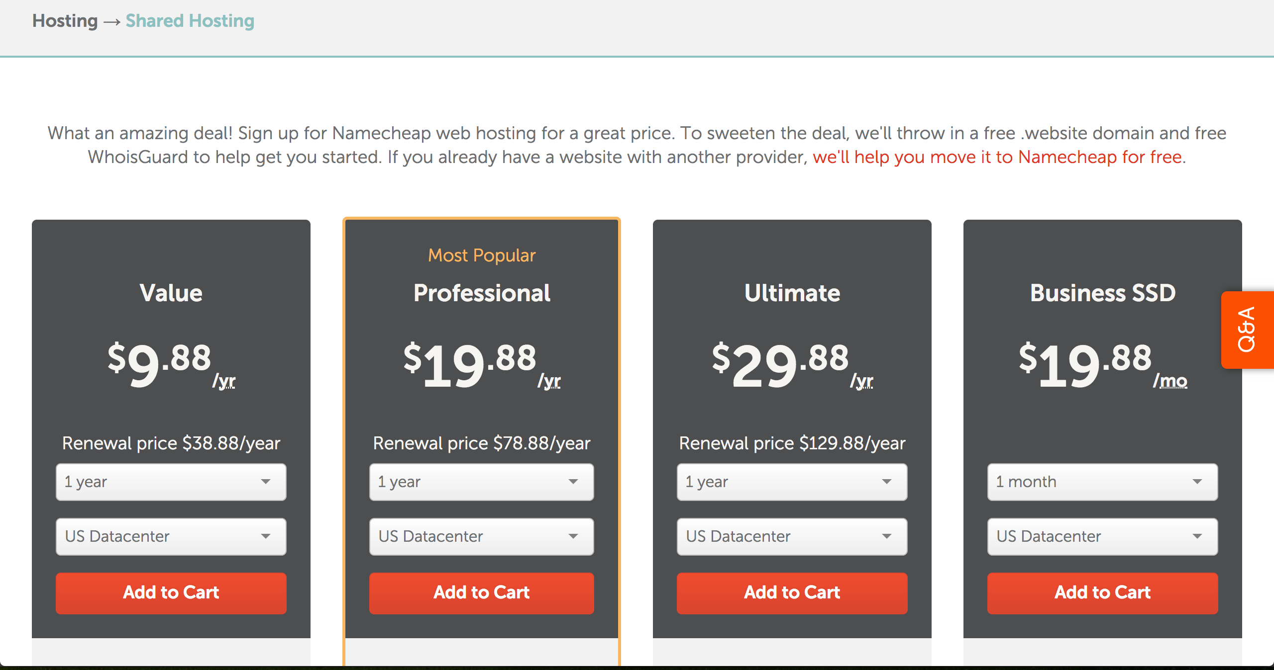

5. Click Add to Cart.

6. If you’re getting a new domain, choose Purchase a New Domain.

If you have a domain name hosted elsewhere, I suggest choosing “Transfer my domain” under the buttons. NameCheap can help walk you through this process if you need assistance.

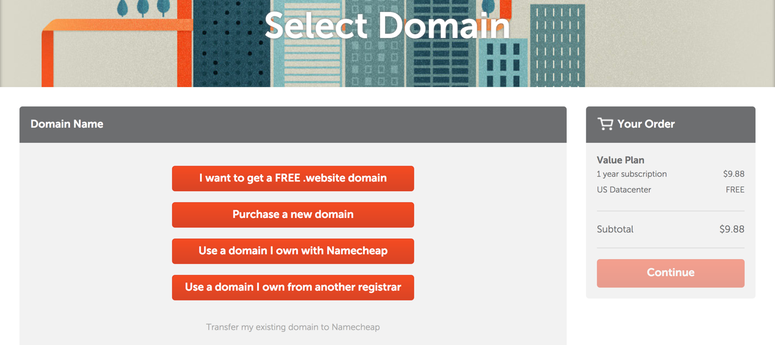

7. For those purchasing a new domain, on the next screen, type in the domain you want to purchase. NameCheap will check to make sure it’s available and will tell you the price.

8. If your domain is available, you can choose Add New Domain to Cart. If it’s not available, you can use the search box to check other domain names.

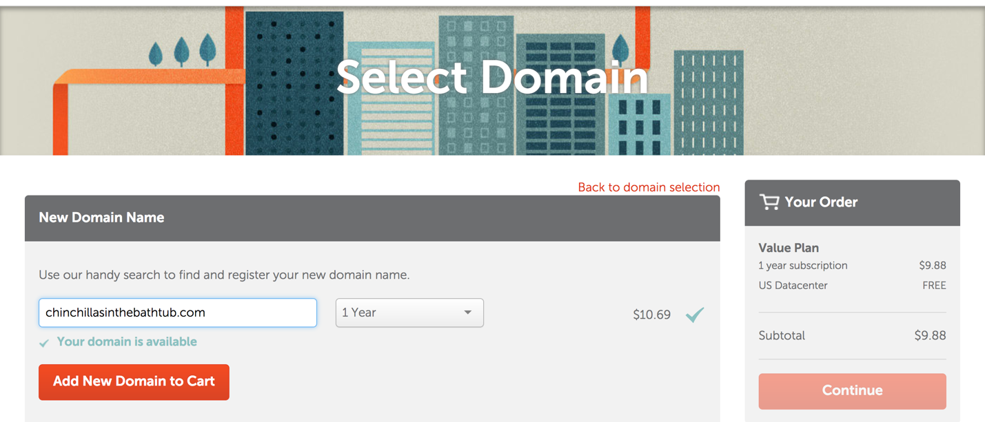

9. The next screen will tell you your totals and should confirm that you have selected both hosting (listed as Value Plan) and a domain name (listed as Domain Registration). If this page is correct, you can Confirm Order at the right side of the screen. If something is missing, you can go back and add it (hosting or domain) to your cart.
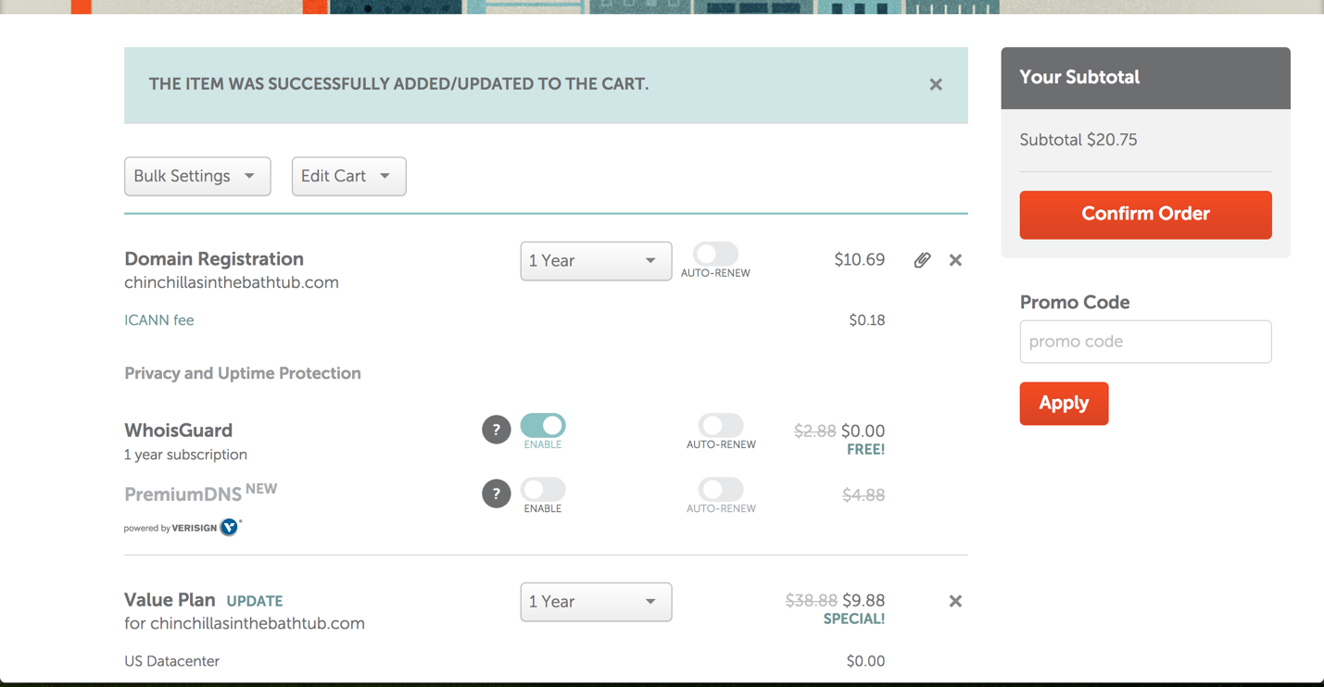

10. Once you confirm order, you can go through the purchase process. When this is complete, NameCheap should send you several confirmation emails. Make sure to save these emails. You will need login details contained in them.

